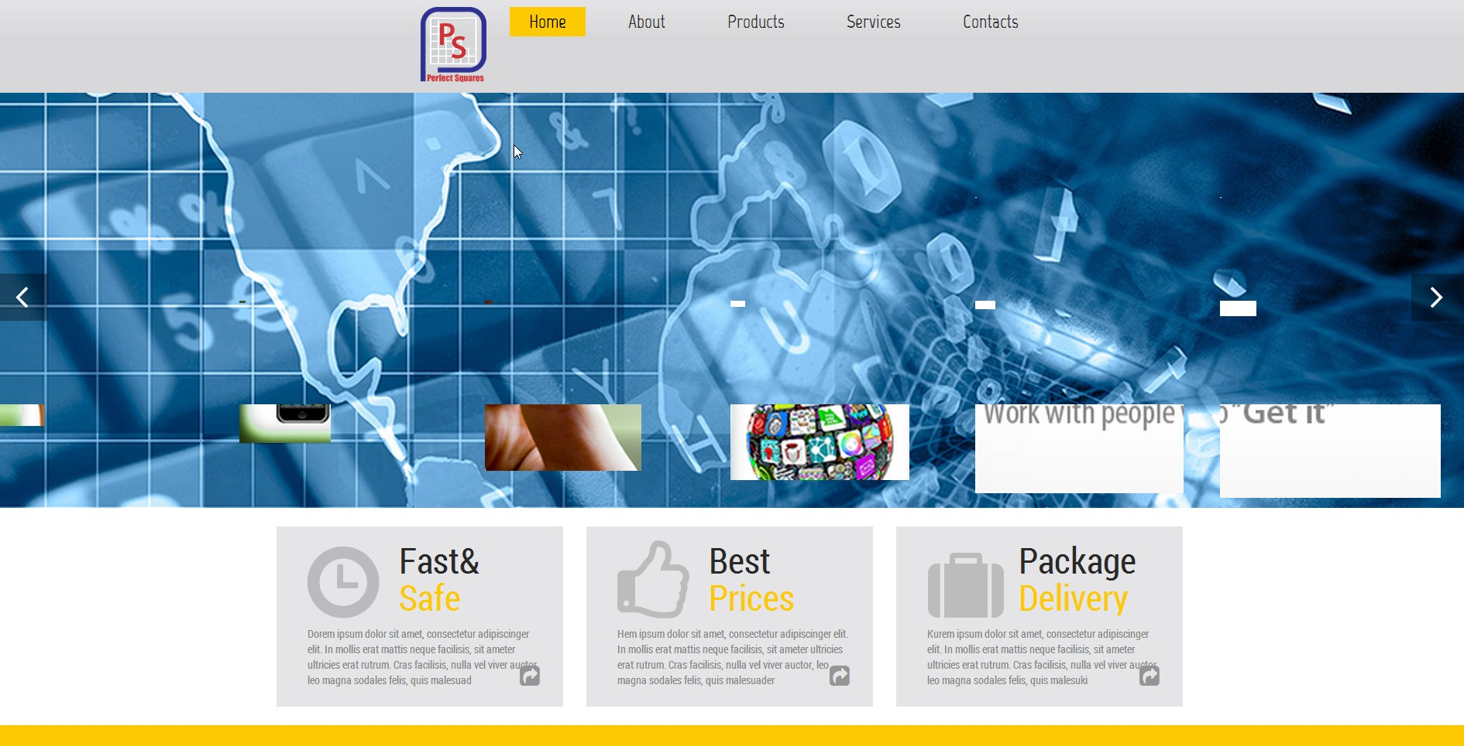

Insert Company Slogan here: “Innovating for the Future” (on every page)

Change title to "Safety": Perfect Stop Sign (PSS)

Change title to "Health Care": include FirstWearable, EastPulse, Remote DIAG/Exam, Homecare System

Title "Optical": include PALeyeD, BlueView, Lens Thickness App, Optician Tools Kit

For this slideshow, have pictures of products that we have and a quick quote about the product from one of our engineers about the product